Contents
CONTENTS

- INTRODUCTION

INTRODUCTION TO PROJECT
PURPOSE OF THE PROJECT
EXISTING SYSTEM
PROPOSED SYSTEM

- SYSTEM ANALYSIS

  - STUDY OF THE SYSTEM
  - INPUT & OUTPUT REPRESENTATION
  - PROCESS MODELS USED WITH JUSTIFICATION
  - SYSTEM ARCHITECTURE

- FEASIBILITY STUDY

  - TECHNICAL FEASIBILITY
  - OPERATIONAL FEASIBILITY
  - ECONOMIC FEASIBILITY

- REQUIREMENT SPECIFICATIONS

  - FUNCIONAL REQUIREMENTS
  - PERFORMANCE REQUIREMENTS
  - SOFTWARE REQUIREMENTS
  - HARDWARE REQUIREMENTS
    - INTRODUCTION TO JAVA
    - Servlets/JSP
    - JDBC
    - Oracle
    - HTML
    - Java Script

- SYSTEM DESIGN

  - . INTRODUCTION
  - DATA FLOW DIAGRAMS
  - UML DIAGRAMS
  - E-R DIAGRAM
  - NORMALIZATION

- OUTPUT SCREENS

- SYSTEM TESTING

  - INTRODUCTION TO TESTING
  - TESTING STRATEGIES

- SYSTEM SECURITY

8.1 INTRODUCTION
8.2 SECURITY IN SOFTWARE

- BIBLIOGRAPHY

Introduction
Chapter - 1
  - INTRODUCTION & OBJECTIVE
‘File Tracking System’ is a web application developed to maintain the status of a file while it is being processing by multiple departments of a Government Organization which may take huge amount of time to process thousands of files.

  - PURPOSE OF THE PROJECT

Introduction: Files will be dispatching among various departments in order to get processed.

Purpose: To track the details of files like, in which department the file is available, under which employee handover the file is available & its status etc. So clients can know the status of file just by logging into the website and leads to saving time.

  - EXISTING SYSTEM & DISADVANTAGES

In present situation in any organization file work is mandatory, so every time moving files from one department other department or from one branch to other branch manually is somewhat difficult. To avoid this problem and to to communicate each and every branch, each and every department we are going to introduce online “File tracking system”.

  - PROPOSED SYSTEM & ITS DISADVANTAGES

The main aim of the project File Tracking System is to provide flexibility to government departments to maintain huge amount of pending files. This system will help all government departments to keep track of every file. This web application is designed for Automation of Department of Industries.

- In this System, We need to process files in Hierarchy and proper action should be taken and necessary permissions are given for the requested Files.
- Sometimes we have to take concern of different departments into consideration.
For Example: - Pollution Board Permissions for some Industries.

Benefits:

- Easy File Tracking

- Restricted Access

- Person Independent Processes

- Senior Management Control

- Web Access Manager

Features provided by File Tracking System are:

- Suitable for any government organization
- Streamlines your processes
- Saves time and money
- Making the organization efficient.

System Analysys
Chapter - 2

2.1 STUDY OF THE SYSTEM
To provide flexibility to the users, the interfaces have been developed that are accessible through a browser. The GUI’S at the top level have been categorized as
- Administrative user interface
- The operational or generic user interface

The ‘administrative user interface’ concentrates on the consistent information that is practically, part of the organizational activities and which needs proper authentication for the data collection. These interfaces help the administrators with all the transactional states like Data insertion, Data deletion and Date updation along with the extensive data search capabilities.

The ‘operational or generic user interface’ helps the end users of the system in transactions through the existing data and required services. The operational user interface also helps the ordinary users in managing their own information in a customized manner as per the included flexibilities

2.2 INPUT & OUTPUT REPRESENTETION

Input design is a part of overall system design. The main objective during the input design is as given below:
- To produce a cost-effective method of input.
- To achieve the highest possible level of accuracy.
- To ensure that the input is acceptable and understood by the user.

INPUT STAGES:
The main input stages can be listed as below:
- Data recording
- Data transcription
- Data conversion
- Data verification
- Data control
- Data transmission
- Data validation
- Data correction

INPUT TYPES:
It is necessary to determine the various types of inputs. Inputs can be categorized as follows:
- External inputs, which are prime inputs for the system.
- Internal inputs, which are user communications with the system.
- Operational, which are computer department’s communications to the system?
- Interactive, which are inputs entered during a dialogue.

INPUT MEDIA:
At this stage choice has to be made about the input media. To conclude about the input media consideration has to be given to;
- Type of input
- Flexibility of format
- Speed
- Accuracy
- Verification methods
- Rejection rates
- Ease of correction
- Storage and handling requirements
- Security
- Easy to use
- Portability
Keeping in view the above description of the input types and input media, it can be said that most of the inputs are of the form of internal and interactive. As
Input data is to be the directly keyed in by the user, the keyboard can be considered to be the most suitable input device.

OUTPUT DESIGN:

In general are:
- External Outputs whose destination is outside the organization.
- Internal Outputs whose destination is within organization and they are the User’s main interface with the computer. Outputs from computer systems are required primarily to communicate the results of processing to users. They are also used to provide a permanent copy of the results for later consultation. The various types of outputs
- Operational outputs whose use is purely with in the computer department.
- Interface outputs, which involve the user in communicating directly with the system.

OUTPUT DEFINITION

The outputs should be defined in terms of the following points:
    - Type of the output
    - Content of the output
    - Format of the output
    - Location of the output
    - Frequency of the output
    - Volume of the output
    - Sequence of the output

It is not always desirable to print or display data as it is held on a computer. It should be decided as which form of the output is the most suitable.

For Example
- Will decimal points need to be inserted
- Should leading zeros be suppressed.

OUTPUT MEDIA:
In the next stage it is to be decided that which medium is the most appropriate for the output. The main considerations when deciding about the output media are:

- The suitability for the device to the particular application.
- The need for a hard copy.
- The response time required.
- The location of the users
- The software and hardware available.

Keeping in view the above description the project is to have outputs mainly coming under the category of internal outputs. The main outputs desired according to the requirement specification are:

The outputs were needed to be generated as a hard copy and as well as queries to be viewed on the screen. Keeping in view these outputs, the format for the output is taken from the outputs, which are currently being obtained after manual processing. The standard printer is to be used as output media for hard copies.

Stages in SDLC:

- Requirement Gathering
- Analysis
- Designing
- Coding
- Testing
- Maintenance
Requirements Gathering stage:

The requirements gathering process takes as its input the goals identified in the high-level requirements section of the project plan. Each goal will be refined into a set of one or more requirements. These requirements define the major functions of the intended application, define
Operational data areas and reference data areas, and define the initial data entities. Major functions include critical processes to be managed, as well as mission critical inputs, outputs and reports. A user class hierarchy is developed and associated with these major functions, data areas, and data entities. Each of these definitions is termed a Requirement. Requirements are identified by unique requirement identifiers and, at minimum, contain a requirement title and textual description.
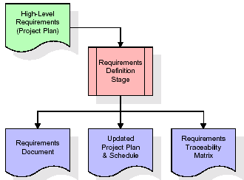

These requirements are fully described in the primary deliverables for this stage: the Requirements Document and the Requirements Traceability Matrix (RTM). The requirements document contains complete descriptions of each requirement, including diagrams and references to external documents as necessary. Note that detailed listings of database tables and fields are not included in the requirements document.
The title of each requirement is also placed into the first version of the RTM, along with the title of each goal from the project plan. The purpose of the RTM is to show that the product components developed during each stage of the software development lifecycle are formally connected to the components developed in prior stages.

In the requirements stage, the RTM consists of a list of high-level requirements, or goals, by title, with a listing of associated requirements for each goal, listed by requirement title. In this hierarchical listing, the RTM shows that each requirement developed during this stage is formally linked to a specific product goal. In this format, each requirement can be traced to a specific product goal, hence the term requirements traceability.
The outputs of the requirements definition stage include the requirements document, the RTM, and an updated project plan.
- Feasibility study is all about identification of problems in a project.
- No. of staff required to handle a project is represented as Team Formation, in this case only modules are individual tasks will be assigned to employees who are working for that project.
- Project Specifications are all about representing of various possible inputs submitting to the server and corresponding outputs along with reports maintained by administrator
Analysis Stage:

The planning stage establishes a bird's eye view of the intended software product, and uses this to establish the basic project structure, evaluate feasibility and risks associated with the project, and describe appropriate management and technical approaches.
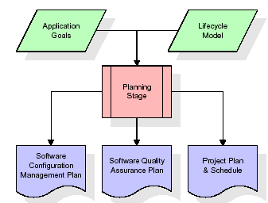

The most critical section of the project plan is a listing of high-level product requirements, also referred to as goals. All of the software product requirements to be developed during the requirements definition stage flow from one or more of these goals. The minimum information for each goal consists of a title and textual description, although additional information and references to external documents may be included. The outputs of the project planning stage are the configuration management plan, the quality assurance plan, and the project plan and schedule, with a detailed listing of scheduled activities for the upcoming Requirements stage, and high level estimates of effort for the out stages.

Designing Stage:

The design stage takes as its initial input the requirements identified in the approved requirements document. For each requirement, a set of one or more design elements will be produced as a result of interviews, workshops, and/or prototype efforts. Design elements describe the desired software features in detail, and generally include functional hierarchy diagrams, screen layout diagrams, tables of business rules, business process diagrams, pseudo code, and a complete entity-relationship diagram with a full data dictionary. These design elements are intended to describe the software in sufficient detail that skilled programmers may develop the software with minimal additional input.
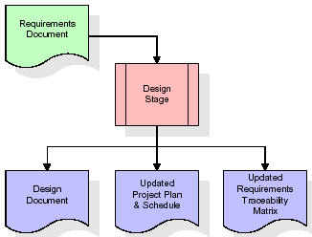

When the design document is finalized and accepted, the RTM is updated to show that each design element is formally associated with a specific requirement. The outputs of the design stage are the design document, an updated RTM, and an updated project plan.

Development (Coding) Stage:

The development stage takes as its primary input the design elements described in the approved design document. For each design element, a set of one or more software artifacts will be produced. Software artifacts include but are not limited to menus, dialogs, data management forms, data reporting formats, and specialized procedures and functions. Appropriate test cases will be developed for each set of functionally related software artifacts, and an online help system will be developed to guide users in their interactions with the software.
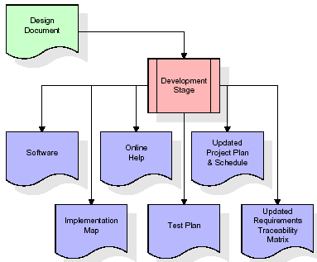

The RTM will be updated to show that each developed artifact is linked to a specific design element, and that each developed artifact has one or more corresponding test case items. At this point, the RTM is in its final configuration. The outputs of the development stage include a fully functional set of software that satisfies the requirements and design elements previously documented, an online help system that describes the operation of the software, an implementation map that identifies the primary code entry points for all major system functions, a test plan that describes the test cases to be used to validate the correctness and completeness of the software, an updated RTM, and an updated project plan.

Integration & Test Stage:

During the integration and test stage, the software artifacts, online help, and test data are migrated from the development environment to a separate test environment. At this point, all test cases are run to verify the correctness and completeness of the software. Successful execution of the test suite confirms a robust and complete migration capability. During this stage, reference data is finalized for production use and production users are identified and linked to their appropriate roles. The final reference data (or links to reference data source files) and production user list are compiled into the Production Initiation Plan.
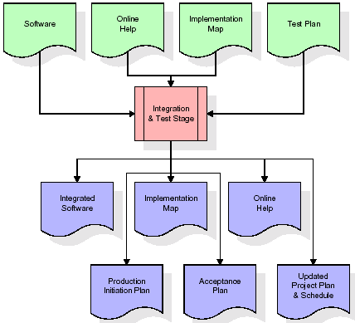

The outputs of the integration and test stage include an integrated set of software, an online help system, an implementation map, a production initiation plan that describes reference data and production users, an acceptance plan which contains the final suite of test cases, and an updated project plan.

- Installation & Acceptance Test:

During the installation and acceptance stage, the software artifacts, online help, and initial production data are loaded onto the production server. At this point, all test cases are run to verify the correctness and completeness of the software. Successful execution of the test suite is a prerequisite to acceptance of the software by the customer.
After customer personnel have verified that the initial production data load is correct and the test suite has been executed with satisfactory results, the customer formally accepts the delivery of the software.
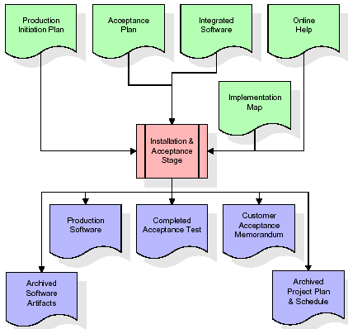
The primary outputs of the installation and acceptance stage include a production application, a completed acceptance test suite, and a memorandum of customer acceptance of the software. Finally, the PDR enters the last of the actual labor data into the project schedule and locks the project as a permanent project record. At this point the PDR "locks" the project by archiving all software items, the implementation map, the source code, and the documentation for future reference.

Maintenance:

Outer rectangle represents maintenance of a project, Maintenance team will start with requirement study, understanding of documentation later employees will be assigned work and they will undergo training on that particular assigned category.
For this life cycle there is no end, it will be continued so on like an umbrella (no ending point to umbrella sticks).
2.4 SYSTEM ARCHITECTURE
Architecture flow:
Below architecture diagram represents mainly flow of requests from users to database through servers. In this scenario overall system is designed in three tires separately using three layers called presentation layer, business logic layer and data link layer. This project was developed using 3-tier architecture.

User
Data Base
Request
Response
SERVER

URL Pattern:

Presentation Layer

SERVLETS AT THE SERVER SIDE

URL Request sent through the browser

Response sent from the servlet
DATABASE
Verifying or updating the database through a statement
Reply from the database according to the statement

URL pattern represents how the requests are flowing through one layer to another layer and how the responses are getting by other layers to presentation layer through server in architecture diagram.

FEASIBILITY STUDY
Chapter -3

Feasibility Study:

Preliminary investigation examines project feasibility, the likelihood the system will be useful to the organization. The main objective of the feasibility study is to test the Technical, Operational and Economical feasibility for adding new modules and debugging old running system. All systems are feasible if they are given unlimited resources and infinite time. There are aspects in the feasibility study portion of the preliminary investigation:
- Technical Feasibility
- Operation Feasibility
- Economic Feasibility

3.1 TECHNICAL FEASIBILITY

The technical issue usually raised during the feasibility stage of the investigation includes the following:
- Does the necessary technology exist to do what is suggested?
- Do the proposed equipments have the technical capacity to hold the data required to use the new system?
- Will the proposed system provide adequate response to inquiries, regardless of the number or location of users?
- Can the system be upgraded if developed?
Are there technical guarantees of accuracy, reliability, ease of access and data security?

3.2 OPERATIONAL FEASIBILITY

OPERATIONAL FEASIBILITY

User-friendly
Customer will use the forms for their various transactions i.e. for adding new routes, viewing the routes details. Also the Customer wants the reports to view the various transactions based on the constraints. These forms and reports are generated as user-friendly to the Client.
Reliability
The package wills pick-up current transactions on line. Regarding the old transactions, User will enter them in to the system.
Security
The web server and database server should be protected from hacking, virus etc
Portability
The application will be developed using standard open source software (Except Oracle) like Java, tomcat web server, Internet Explorer Browser etc these software will work both on Windows and Linux o/s. Hence portability problems will not arise.
Availability

This software will be available always.

Maintainability

The system called the ewheelz uses the 2-tier architecture. The 1st tier is the GUI, which is said to be front-end and the 2nd tier is the database, which uses My-Sql, which is the back-end.
The front-end can be run on different systems (clients). The database will be running at the server. Users access these forms by using the user-ids and the passwords.

3.3 ECONOMIC FEASILITY

The computerized system takes care of the present existing system’s data flow and procedures completely and should generate all the reports of the manual system besides a host of other management reports.
It should be built as a web based application with separate web server and database server. This is required as the activities are spread throughout the organization customer wants a centralized database. Further some of the linked transactions take place in different locations.
Open source software like TOMCAT, JAVA, Mysql and Linux is used to minimize the cost for the Customer.

REQUIREMENTS SPECIFICATION
Chapter -4

4.1 FUNCTIONAL REQUIREMENTS SPECIFICATION

This application has been divided in to four modules

1. Admin Module:

- In this module Administrator will add users to work with files.
- He can check exact status of the files and he receives completed files from other departments.
- Administrator can delete the files from database after processing of files. Administrator can see the pending files list.

2. Department Module:

- The users are
    - Clerk
    - Superintendent
    - Deputy secretary
    - Additional Secretary
    - Secretary
    - Ministry

- All the above users receive the files from other departments to be processed.
- He can accept or reject the files from other departments.
- After completion of process they dispatch the file to any other department.

3. Client Module:

- Client can check the exact status of the file in which department it is processing.
- If the file is rejected he can see the reason for the rejection.
4. Reports Module:
In this module administrator will get different types of reports like Number of employees of a company and files uploaded etc. This module is controlled by administrator only.

4.2 PERFORMANCE REQUIREMENTS

Performance is measured in terms of the output provided by the application. Requirement specification plays an important part in the analysis of a system. Only when the requirement specifications are properly given, it is possible to design a system, which will fit into required environment. It rests largely with the users of the existing system to give the requirement specifications because they are the people who finally use the system. This is because the requirements have to be known during the initial stages so that the system can be designed according to those requirements. It is very difficult to change the system once it has been designed and on the other hand designing a system, which does not cater to the requirements of the user, is of no use.
The requirement specification for any system can be broadly stated as given below:
- The system should be able to interface with the existing system
- The system should be accurate
- The system should be better than the existing system
The existing system is completely dependent on the user to perform all the duties.

SYSTEM DESIGN
Chapter - 5

5.1 INTRODUCTION
Systems design
Introduction: Systems design is the process or art of defining the architecture, components, modules, interfaces, and data for a system to satisfy specified requirements. One could see it as the application of systems theory to product development. There is some overlap and synergy with the disciplines of systems analysis, systems architecture and systems engineering.

5.2 DATA FLOW DIAGRAMS

Context Level DFD

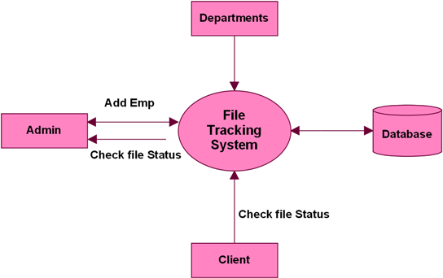

Level 0 DFD

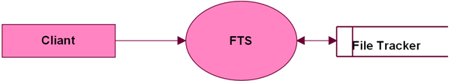

Level 0 Client Module:

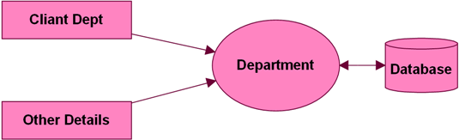

Level 0 Admin Module:

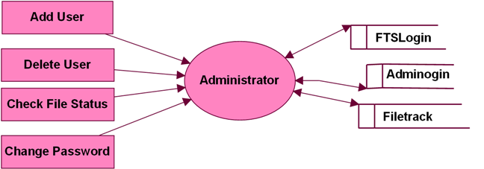

Level 1 Clerk Department:

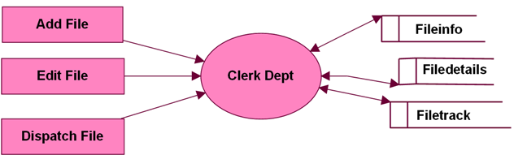

Level 1 Other Department:

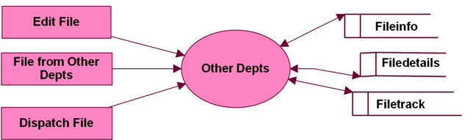

Level 0 for Edit File:

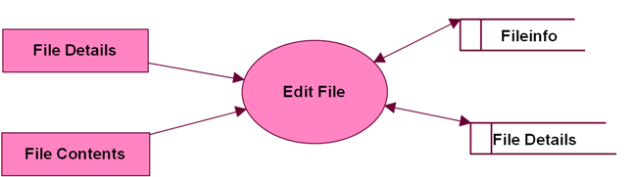

Level 0 DFD for User:

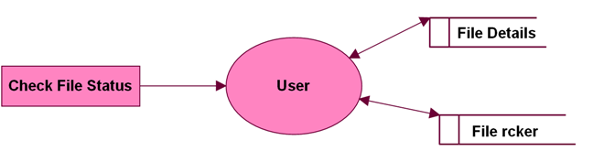

5.3 UML DIAGRAMS

Unified Modeling Language:

The Unified Modeling Language allows the software engineer to express an analysis model using the modeling notation that is governed by a set of syntactic semantic and pragmatic rules.

A UML system is represented using five different views that describe the system from distinctly different perspective. Each view is defined by a set of diagram, which is as follows.
  - User Model View
    - This view represents the system from the user’s perspective.
    - The analysis representation describes a usage scenario from the end-users perspective.

  - Structural model view
    - In this model the data and functionality are arrived from inside the system.
    - This model view models the static structures.

- Behavioral Model View
It represents the dynamic of behavioral as parts of the system, depicting the interactions of collection between various structural elements described in the user model and structural model view.

- Implementation Model View
In this the structural and behavioral as parts of the system are represented as they are to be built.

- Environmental Model View

In this the structural and behavioral aspects of the environment in which the system is to be implemented are represented.

UML is specifically constructed through two different domains they are:
- UML Analysis modeling, this focuses on the user model and structural model views of the system.
- UML design modeling, which focuses on the behavioral modeling, implementation modeling and environmental model views.

Use case Diagrams represent the functionality of the system from a user’s point of view. Use cases are used during requirements elicitation and analysis to represent the functionality of the system. Use cases focus on the behavior of the system from external point of view.

Actors are external entities that interact with the system. Examples of actors include users like administrator, bank customer …etc., or another system like central database.

UML DIAGRAMS

Use-case-diagram

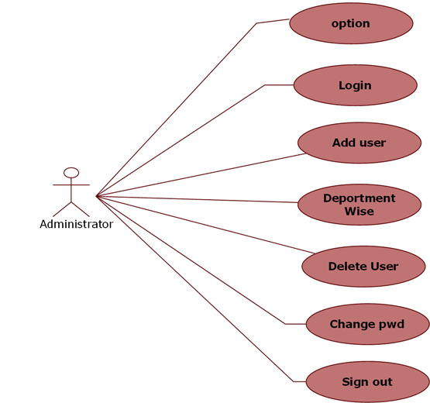

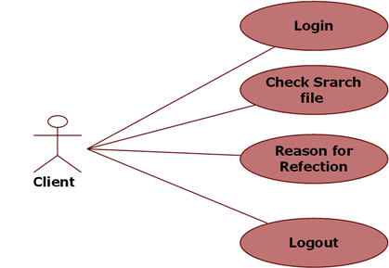

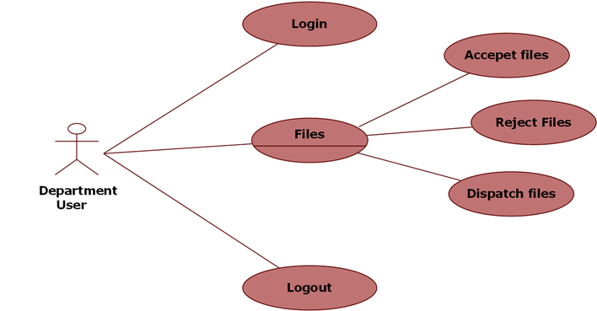

Class Diagram:

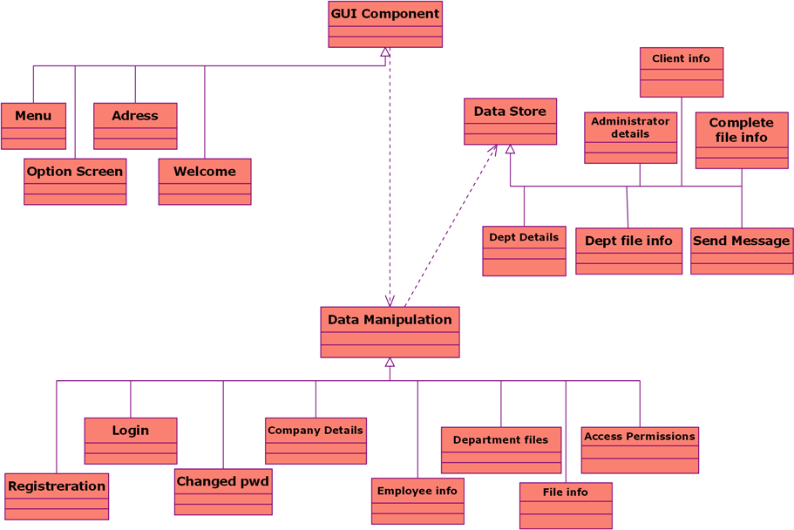

Sequence Diagrams:

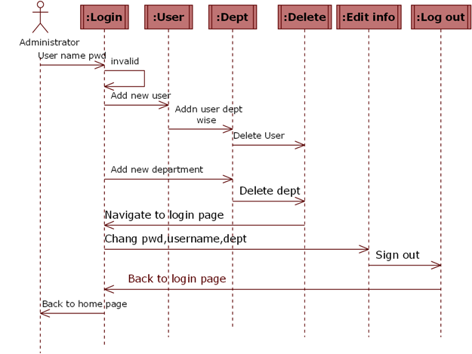

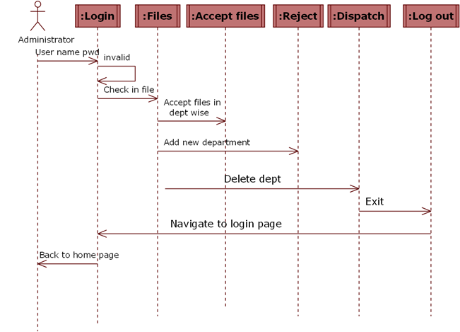

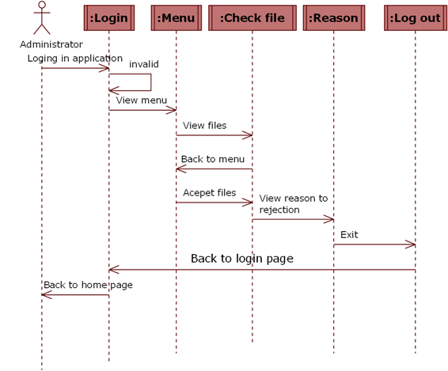

State Diagrams:
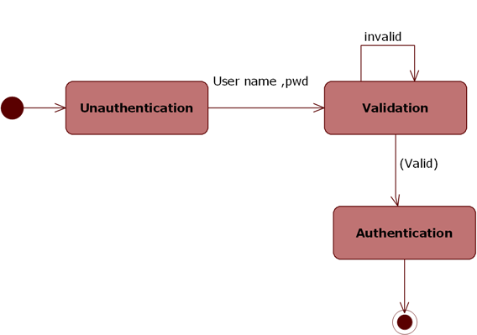

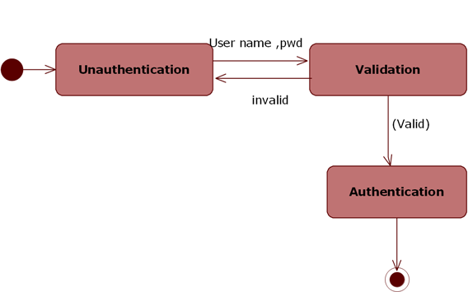

5.4. ER DIAGRAMS

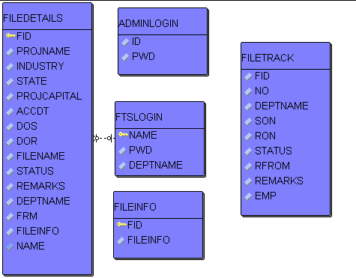

5.5. NORMALIZATION

A Database is a collection of interrelated data stored with a minimum of redundancy to serve many applications. The database design is used to group data into a number of tables and minimizes the artificiality embedded in using separate files. The tables are organized to:

- Reduced duplication of data.
- Simplify functions like adding, deleting, modifying data etc..,
- Retrieving data
- Clarity and ease of use
- More information at low cost

Normalization

Normalization is built around the concept of normal forms. A relation is said to be in a particular normal form if it satisfies a certain specified set of constraints on the kind of functional dependencies that could be associated with the relation. The normal forms are used to ensure that various types of anomalies and inconsistencies are not introduced into the database.

First Normal Form:

A relation R is in first normal form if and only if all underlying domains contained atomic values only.

Second Normal Form:

A relation R is said to be in second normal form if and only if it is in first normal form and every non-key attribute is fully dependent on the primary key.

Third Normal Form:

A relation R is said to be in third normal form if and only if it is in second normal form and every non key attribute is non-transitively depend on the primary key.

OUTPUT SCREENS
Chapter -6

SYSTEM TESTING
Chapter -7

7.1 INTRODUCTION TO TESTING

Introduction to Testing:
Testing is a process, which reveals errors in the program. It is the major quality measure employed during software development. During software development. During testing, the program is executed with a set of test cases and the output of the program for the test cases is evaluated to determine if the program is performing as it is expected to perform.

7.2 TESTING IN STRATEGIES

In order to make sure that the system does not have errors, the different levels of testing strategies that are applied at differing phases of software development are:
Unit Testing:

Unit Testing is done on individual modules as they are completed and become executable. It is confined only to the designer's requirements.

Each module can be tested using the following two Strategies:
Black Box Testing:
In this strategy some test cases are generated as input conditions that fully execute all functional requirements for the program. This testing has been uses to find errors in the following categories:
- Incorrect or missing functions
- Interface errors
- Errors in data structure or external database access
- Performance errors
- Initialization and termination errors.
In this testing only the output is checked for correctness.

The logical flow of the data is not checked.

White Box testing:
In this the test cases are generated on the logic of each module by drawing flow graphs of that module and logical decisions are tested on all the cases. It has been uses to generate the test cases in the following cases:
- Guarantee that all independent paths have been executed.
- Execute all logical decisions on their true and false Sides.
- Execute all loops at their boundaries and within their operational bounds
- Execute internal data structures to ensure their validity.

Integrating Testing:

Integration testing ensures that software and subsystems work together a whole. It tests the interface of all the modules to make sure that the modules behave properly when integrated together.

System Testing:

Involves in-house testing of the entire system before delivery to the user. Its aim is to satisfy the user the system meets all requirements of the client's specifications.

Acceptance Testing:

It is a pre-delivery testing in which entire system is tested at client's site on real world data to find errors.

Test Approach:

Testing can be done in two ways:

- Bottom up approach
- Top down approach

Bottom up Approach:

Testing can be performed starting from smallest and lowest level modules and proceeding one at a time. For each module in bottom up testing a short program executes the module and provides the needed data so that the module is asked to perform the way it will when embedded within the larger system. When bottom level modules are tested attention turns to those on the next level that use the lower level ones they are tested individually and then linked with the previously examined lower level modules.
Top down approach:
This type of testing starts from upper level modules. Since the detailed activities usually performed in the lower level routines are not provided stubs are written. A stub is a module shell called by upper level module and that when reached properly will return a message to the calling module indicating that proper interaction occurred. No attempt is made to verify the correctness of the lower level module.

Validation:
The system has been tested and implemented successfully and thus ensured that all the requirements as listed in the software requirements specification are completely fulfilled. In case of erroneous input corresponding error messages are displayed

SYSTEM SECURITY
Chapter -8

8.1 INTRODUCTION

System Security:
Setting Up Authentication for Web Applications
Introduction:
To configure authentication for a Web Application, use the <login-config> element of the web.xml deployment descriptor. In this element you define the security realm containing the user credentials, the method of authentication, and the location of resources for authentication.

8.2 SECURITY IN SOFTWARE
To set up authentication for Web Applications:
- Open the web.xml deployment descriptor in a text editor or use the Administration Console. Specify the authentication method using the <auth-method> element. The available options are:
BASIC
Basic authentication uses the Web Browser to display a username/password dialog box. This username and password is authenticated against the realm.
FORM
Form-based authentication requires that you return an HTML form containing the username and password. The fields returned from the form elements must be: j_username and j_password, and the action attribute must be j_security_check. Here is an example of the HTML coding for using FORM authentication:
<form method="POST" action="j_security_check">
<inputtype="text"name="j_username">
<input type="password" name="j_password">
</form>
The resource used to generate the HTML form may be an HTML page, a JSP, or a servlet. You define this resource with the <form-login-page> element.
The HTTP session object is created when the login page is served. Therefore, the session.isNew() method returns FALSE when called from pages served after successful authentication.

